**Variance**

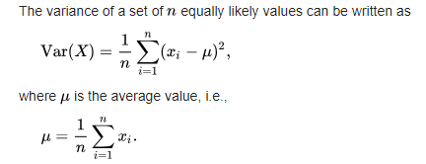

**Standard Deviation**

Square root of Variance is called standard deviation.

**Covariance**

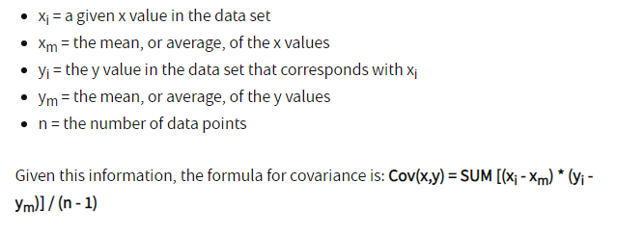

Standard Deviation vs. Variance

The variance helps determine the data's spread size when compared to the mean value. As the variance gets bigger, more variation in data values occurs, and there may be a larger gap between one data value and another. If the data values are all close together, the variance will be smaller. This is more difficult to grasp than are standard deviations, however, because variances represent a squared result that may not be meaningfully expressed on the same graph as the original dataset.

Standard deviations are usually easier to picture and apply. The standard deviation is expressed in the same unit of measurement as the data, which isn't necessarily the case with the variance. Using the standard deviation, statisticians may determine if the data has a normal curve or other mathematical relationship. If the data behaves in a normal curve, then 68 percent of the data points will fall within one standard deviation of the average, or mean data point. Bigger variances cause more data points to fall outside the standard deviation. Smaller variances result in more data that is close to average.

What's Standard Deviance Used For?

Standard deviation is an especially useful tool in investing and trading strategies as it helps measure market and [security](https://www.investopedia.com/terms/s/security.asp) volatility – and predict performance trends.

As it relates to investing, for example, one can expect an [index fund](https://www.investopedia.com/terms/i/indexfund.asp) to have a low standard deviation versus its [benchmark](https://www.investopedia.com/terms/b/benchmark.asp) index, as the fund's goal is to replicate the index. On the other hand, one can expect [aggressive growth funds](https://www.investopedia.com/terms/a/aggressivegrowthfund.asp) to have a high standard deviation from relative stock indices, as their portfolio managers make aggressive bets to generate higher-than-average returns.

A lower standard deviation isn't necessarily preferable. It all depends on the investments one is making, and one's willingness to assume risk. When dealing with the amount of deviation in their portfolios, investors should consider their personal tolerance for volatility and their overall investment objectives. More aggressive investors may be comfortable with an investment strategy that opts for vehicles with higher-than-average volatility, while more conservative investors may not.